**MONOPOLY**

Long Run equilibrium:

In the long run the monopolist has the time to expand his plant, or to use his existing plant at any level which will maximize his profit. With entry blocked, it is not necessary for the monopolist to reach an optimal scale (that is, to build up his plant until he reaches the minimum point of the LAC). Neither is there any guarantee that he will use his existing plant at optimum capacity. What is certain is that the monopolist will not stay in business if he makes losses in the long run. He will most probably continue to earn supernormal profits even in the long run, given that entry is barred. However, the size of his plant and the degree of utilization of any given plant size depend entirely on the market demand. He may reach the optimal scale (minimum point of LAC) or remain at suboptimal scale (falling part of his LAC) or surpass the optimal scale (expand beyond the minimum LAC) depending on the market conditions. In figure 6.5 we depict

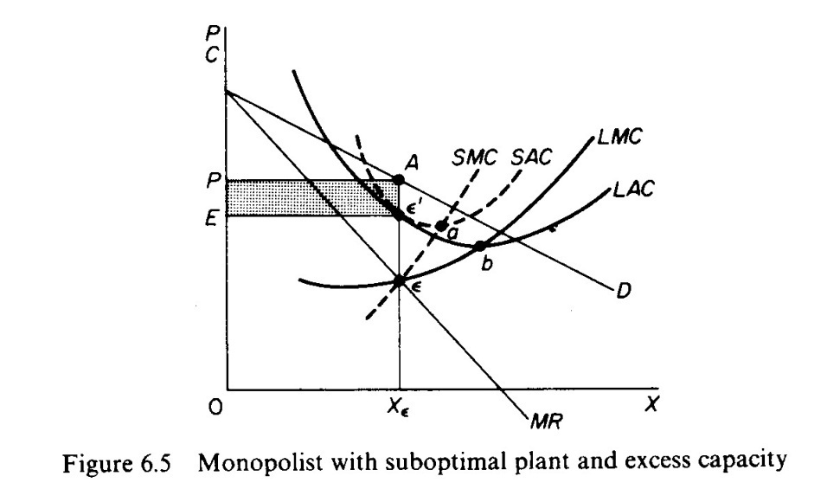

the case in which the market size does not permit the monopolist to expand to the minimum point of *LAC.* In this case not only is his plant of suboptimal size (in the sense that the full economies of scale are not exhausted) but also the existing plant is under-utilized. This is because to the left of the minimum point of the *LAC* the *SRAC is* tangent to the *LAC* at its falling part, and also because the short-run *MC* must be equal to the *LRMC.* This occurs at *r,* while the minimum *LAC is* at *b* and the optimal use of the existing plant is at *a.* Since it is utilised at the level *c',* there is excess capacity.

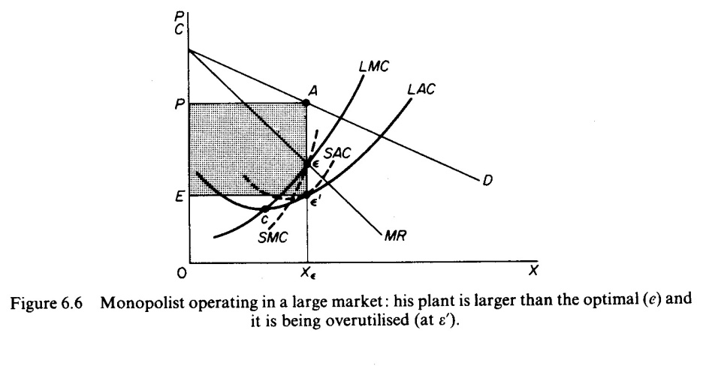

In figure 6.6 we depict the case where the size of the market is so large that the monop­olist, in order to maximise his output, must build a plant larger than the optimal and over-utilize it. This is because to the right of the minimum point of the *LAC* the *SRAC*

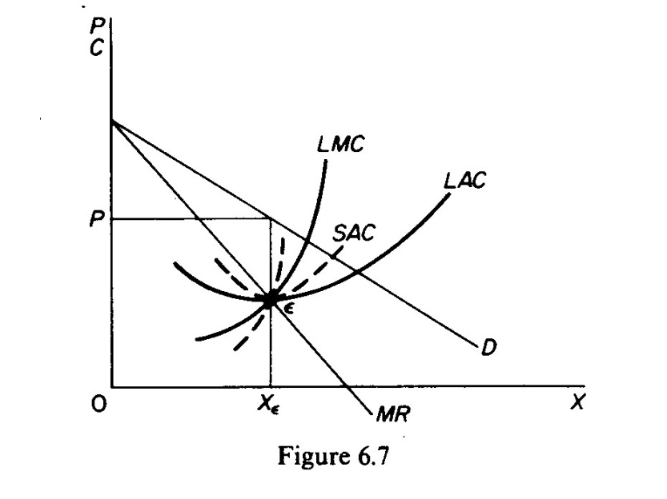

and the *LAC* are tangent at a point of their positive slope, and also because the *SRMC* must be equal to the *LAC.* Thus the plant that maximizes the monopolist's profits leads to higher costs for two reasons: firstly because it is larger than the optimal size, and secondly because it is over utilized. This is often the case with public utility companies operating at national level.

Finally in figure 6.7 we show the case in which the market size is just large enough to permit the monopolist to build the optimal plant and use it at full capacity.

It should be clear that which of the above situations will emerge in any particular case depends on the size of the market (given the technology of the monopolist). There is no certainty that in the long run the monopolist will reach the optimal scale, as is the case in a purely competitive market. In monopoly there are no market forces similar to those in pure competition which lead the firms to operate at optimum plant size (and utilize it at its full capacity) in the long run.

IMPOSITION OF A TAX

We will examine the effects on the equilibrium of the monopolist of *(a)* a lump-sum tax, *(b)* a profits tax, *(c)* a specific sales tax.

*Imposition of a lump-sum tax (per period):*

Inthe case of a monopolist we need not distin­guish between the short run and the long run as we did in the purely competitive market because in general the monopolist realizes some excess profits both in the short run and in the long run. Under these conditions the imposition of a lump tax will reduce the excess profits of the monopolist because it will increase his total fixed cost. However, the *MC* curve of the monopolist will not be affected, and hence the equilibrium in the monopoly market will remain the same even in the long run (provided that the lump-sum tax does not exceed the supernormal profits of the monopolist).

*Imposition of a profits tax:*

The effects of taxes on the monopoly profits on the equilibrium of the monopolist are the same as in the case of the lump-sum tax: the profits tax reduces the abnormal (monopoly) profits, but the equilibrium in the market is not affected, so long as the profits tax does not bite into the normal profits of the monopolist, since in this event the monopolist will not be covering his total costs (inclusive of his normal profit) and will close down

*Imposition of a specific sales tax:*

The effects of a specific tax on the output of the monop­olist are broadly the same with those in a purely competitive market. The imposition of the specific tax will shift the *MC* curve of the monopolist upwards, which will result in a change of his equilibrium; in the new equilibrium position (E') the price will be higher and the quantity smaller as compared with the initial equilibrium. This is the same qualitative prediction with the model of pure competition.

The change in the price of the monopolist may be smaller, equal or greater than the specific tax, as in the case of pure competition. However, in the monopoly market we do not distinguish between the short run and the long run, since the conditions of equilibrium are the same in both periods.

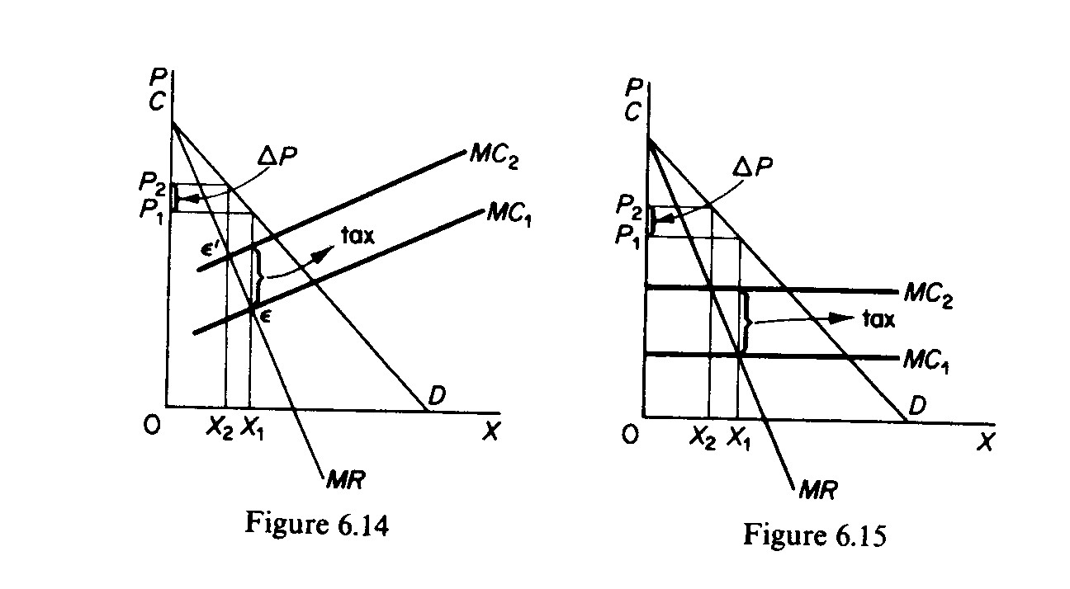

*Firstly.* If the *MC* of the monopolist has a positive slope, the increase in the price will be smaller than the specific tax, as in the case of pure competition. The monopolist will pass to the consumer part of the specific tax (in figure 6.14 ∆P < tax).

*Secondly.* If the *MC* of the monopolist is horizontal, the monopolist will raise the price, but not by the full amount of the tax, as is the case in pure competition. Even when his *MC* curve is infinitely elastic, the monopolist will bear some amount of the specific tax (in figure 6.15 ∆P < tax).

*Thirdly.* The examination of the conditions under which the monopolist can pass the total tax to the consumer by charging a suitably higher price, or can raise the price more than the amount of the tax, is too complicated to be attempted here. The interested reader is referred to textbooks on public finance and public policy.

**The multi plant firm:**

Assume that the monopolist operates two plants, *A* and *B,* each with a different cost structure (figures 6.16 and 6.17). He has to make two decisions:

Firstly, how much output to produce altogether and at what price to sell it so as to maximize profit.

Secondly, how to allocate the production of the optimal (profit-maximizing) output between the two plants.

The monopolist is assumed to know his market demand (and the corresponding *MR* curve) and the cost structure of the different plants. The total *MC* curve of the monopolist may be computed from the horizontal summation of the *MC* curves of the individual plants

MC = MC1 + MC2

Given the *MR* and *MC* curves, the monpolist can define the total output and the price at which it must be sold in order to maximize his profit from the intersection of these two curves (point i; in figure 6.18).

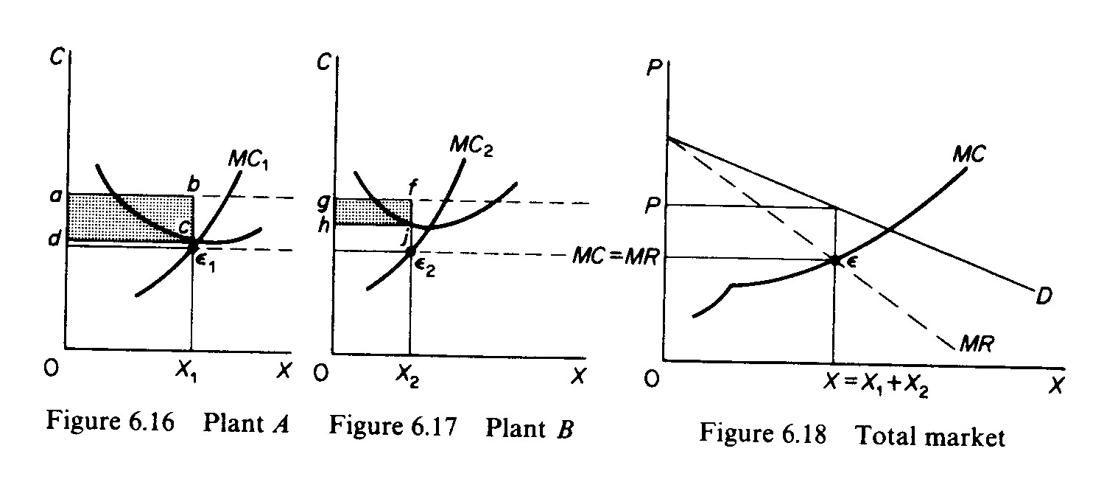The allocation of production between the plants is decided by the marginalistic rule

MR = MC1 = MC2

In other words, the monopolist maximizes his profit by utilizing each plant up to the level at which the marginal costs are equal toeach other and to the common marginal revenue. This is because if the *MC* in one plant, say plant A, is lower than the marginal cost of plant *B,* the monopolist would increase his profit by increasing the production in A and decreasing it in *B,* until the condition is fulfilled.

MR = MC1 = MC2

Graphically the equilibrium of the multi plant monopolist may be defined as follows. The total profit-maximising output and its price is defined by the intersection of *MC* and *MR* curves (point *E* in figure 6.18). From the point of intersection we draw a line, parallel to the *X* axis, until it intersects the individual *MCI* and *MC2* curves of the two plants. At these points the equilibrium condition *(MC = MR = MCI = MC2)* is satisfied. If from these points *(E,* and *E2)* we draw perpendiculars to the X-axis of figures 6.16 and 6.17, we find the level of output that will be produced in each plant. Clearly X, *4- X2* must be equal to the profit-maximizing output *X.* The total profit is the sum of profits from the products of the two plants. The profit from plant *A* is the shaded area *abed* and the profit from plant *B* is the shaded area *gfjh.*